asan@DESKTOP-Q9TH7K5 MINGW64 ~/Deep Learning

$ ls -a

./ ../

vasan@DESKTOP-Q9TH7K5 MINGW64 ~/Deep Learning

$ git init

Initialized empty Git repository in C:/Users/vasan/Deep Learning/.git/

vasan@DESKTOP-Q9TH7K5 MINGW64 ~/Deep Learning (master)

$ git remote -v

vasan@DESKTOP-Q9TH7K5 MINGW64 ~/Deep Learning (master)

$ gti remoter add origin https://github.com/Vasanthdata/deeplearning.git

bash: gti: command not found

vasan@DESKTOP-Q9TH7K5 MINGW64 ~/Deep Learning (master)

$ git remote add origin https://github.com/Vasanthdata/deeplearning.git

vasan@DESKTOP-Q9TH7K5 MINGW64 ~/Deep Learning (master)

$ git remote -v

origin https://github.com/Vasanthdata/deeplearning.git (fetch)

origin https://github.com/Vasanthdata/deeplearning.git (push)

vasan@DESKTOP-Q9TH7K5 MINGW64 ~/Deep Learning (master)

$ git branch

vasan@DESKTOP-Q9TH7K5 MINGW64 ~/Deep Learning (master)

$ git branch

vasan@DESKTOP-Q9TH7K5 MINGW64 ~/Deep Learning (master)

$ git pull origin main

remote: Enumerating objects: 5, done.

remote: Counting objects: 100% (5/5), done.

remote: Compressing objects: 100% (4/4), done.

remote: Total 5 (delta 0), reused 0 (delta 0), pack-reused 0

Unpacking objects: 100% (5/5), 3.01 KiB | 70.00 KiB/s, done.

From https://github.com/Vasanthdata/deeplearning

* branch main -> FETCH_HEAD

* [new branch] main -> origin/main

vasan@DESKTOP-Q9TH7K5 MINGW64 ~/Deep Learning (master)

$

MLOps Project Check it out:

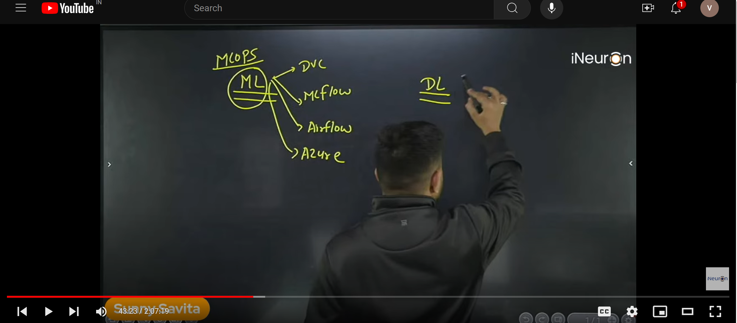

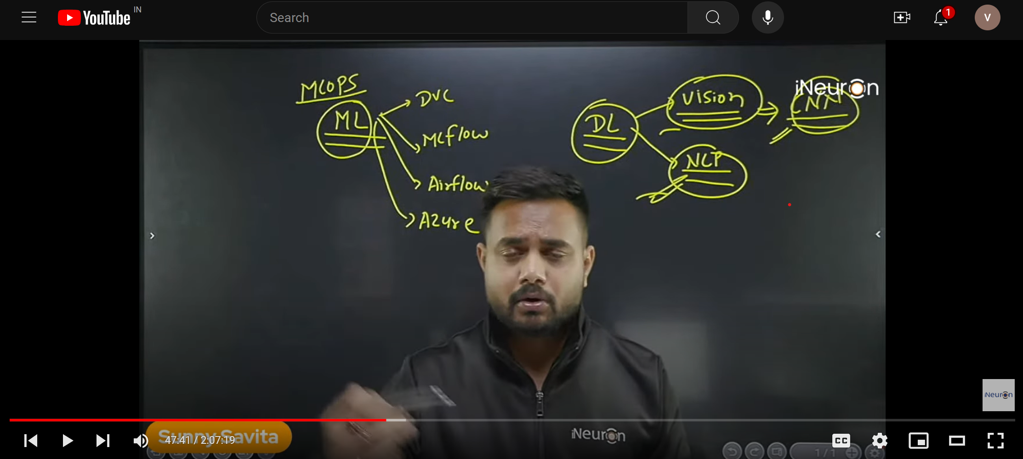

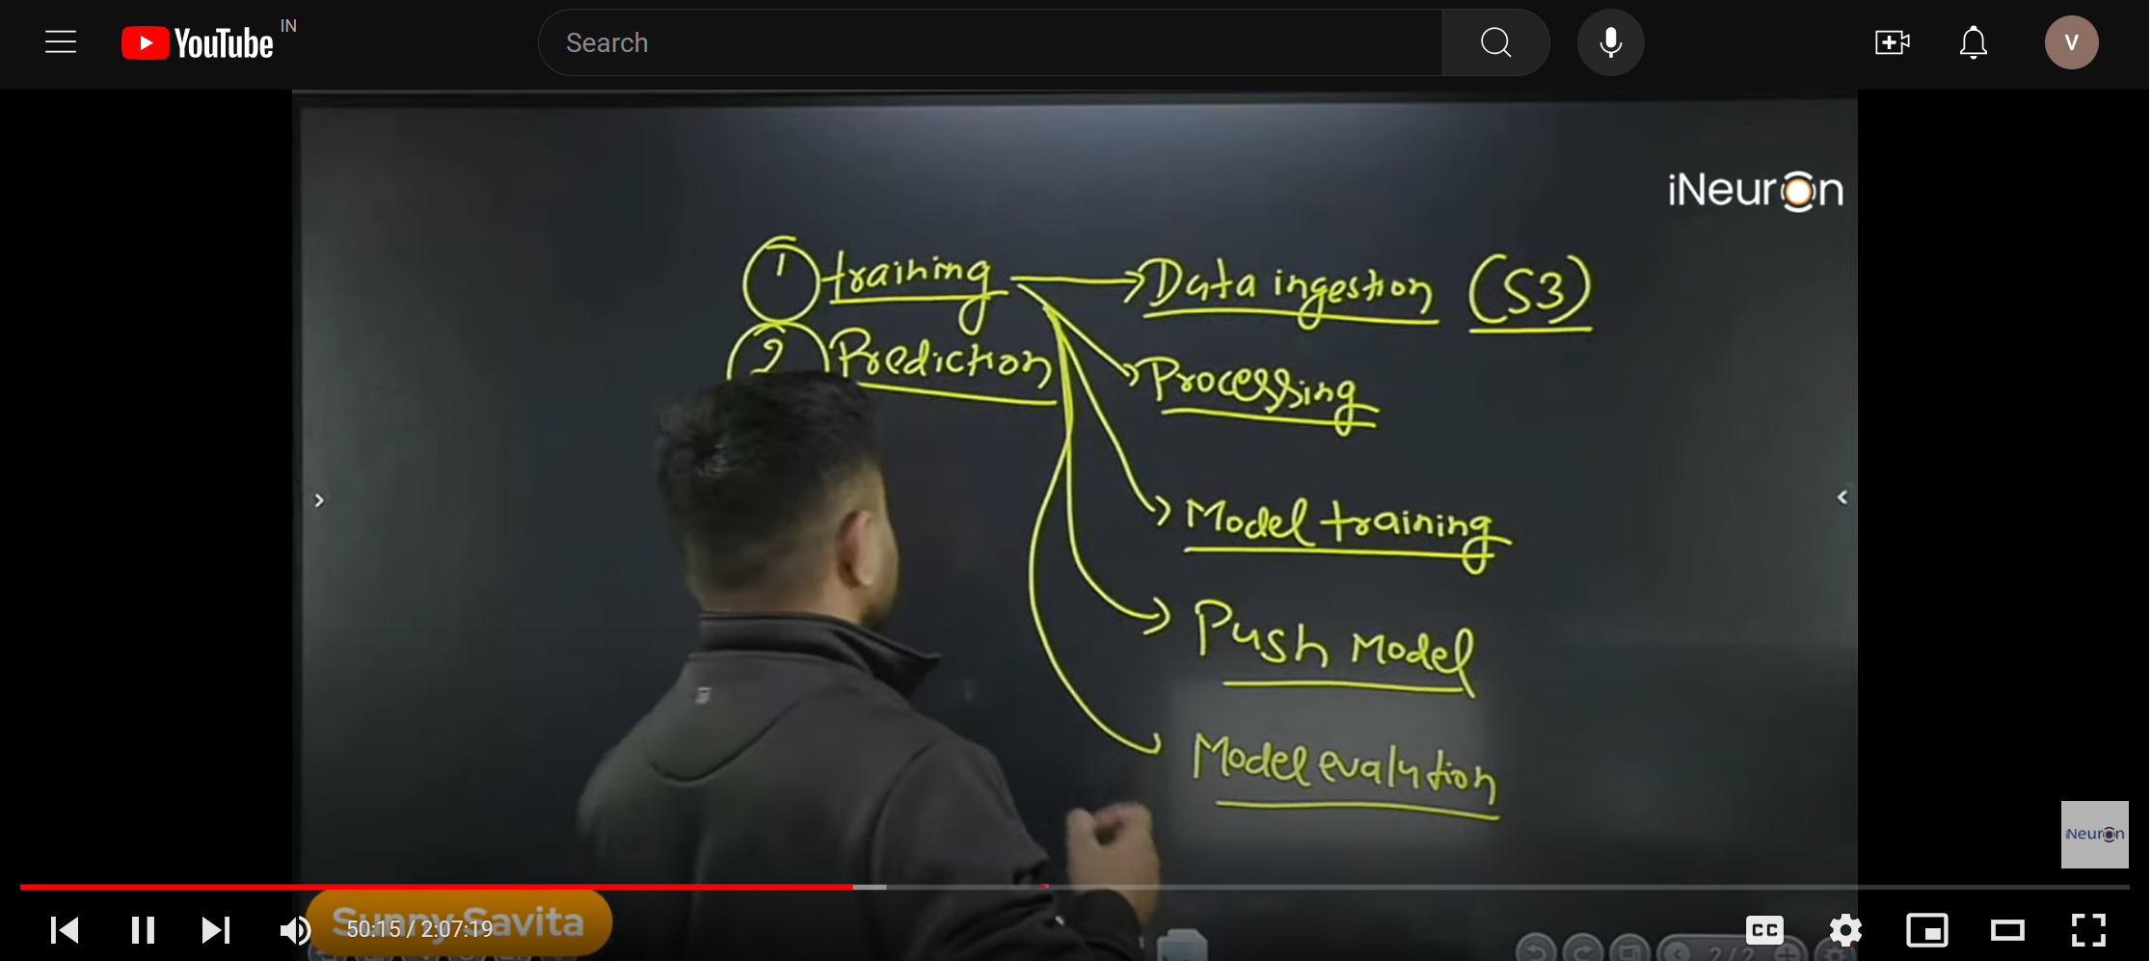

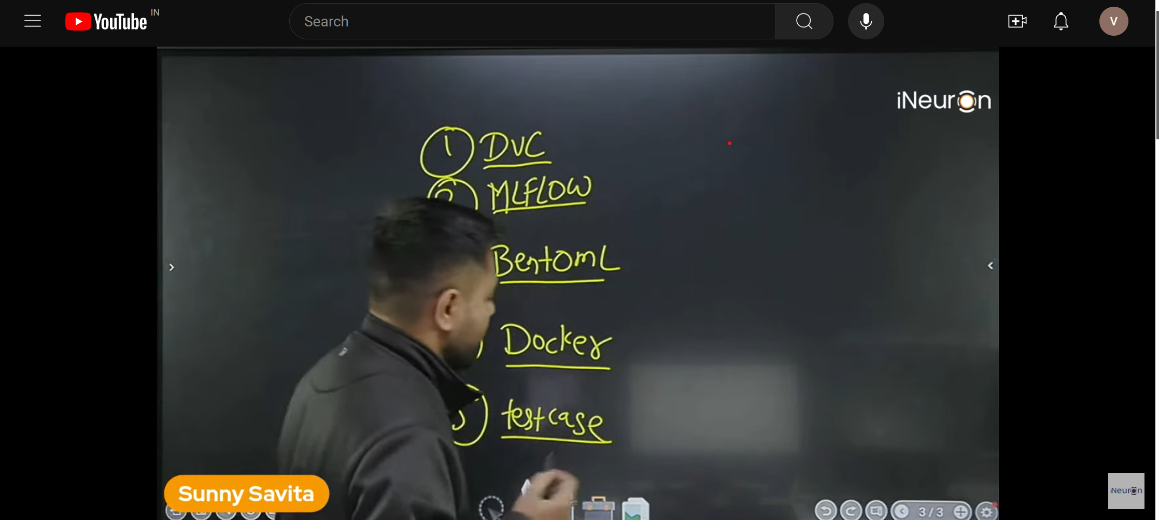

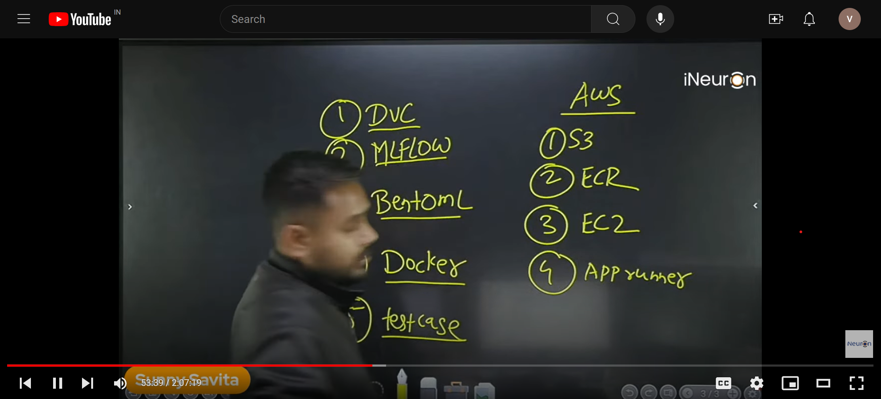

vasan@DESKTOP-Q9TH7K5 MINGW64 ~/Deep Learning (master)

$ git add .

vasan@DESKTOP-Q9TH7K5 MINGW64 ~/Deep Learning (master)

$ git config --global user.email "vasanth634@gmail.com"

vasan@DESKTOP-Q9TH7K5 MINGW64 ~/Deep Learning (master)

$ git commit -m "folder update"

[master db10bc4] folder update

22 files changed, 0 insertions(+), 0 deletions(-)

create mode 100644 .github/workflows/ci.yaml

create mode 100644 .github/workflows/main.yaml

create mode 100644 Deep Learning Notes.docx

create mode 100644 Xray/__init__.py

create mode 100644 Xray/cloud_storage/__init__.py

create mode 100644 Xray/cloud_storage/s3_operation.py

create mode 100644 Xray/components/data_ingestion.py

create mode 100644 Xray/components/data_transformation.py

create mode 100644 Xray/components/model_evaluation.py

create mode 100644 Xray/components/model_pusher.py

create mode 100644 Xray/components/model_training.py

create mode 100644 Xray/entity/artifact_entity.py

create mode 100644 Xray/entity/config_entity.py

create mode 100644 Xray/exception.py

create mode 100644 Xray/logger.py

create mode 100644 Xray/pipeline/training_pipeline.py

create mode 100644 bentofile.yaml

create mode 100644 requirements.txt

create mode 100644 setup.py

create mode 100644 test/integrationtest/__init__.py

create mode 100644 test/unittest/__init__.py

create mode 100644 ~$ep Learning Notes.docx

vasan@DESKTOP-Q9TH7K5 MINGW64 ~/Deep Learning (master)

$ git push origin main

error: src refspec main does not match any

error: failed to push some refs to 'https://github.com/Vasanthdata/deeplearning.git'

vasan@DESKTOP-Q9TH7K5 MINGW64 ~/Deep Learning (master)

$ git config user.email

vasanth634@gmail.com

vasan@DESKTOP-Q9TH7K5 MINGW64 ~/Deep Learning (master)

$ git config user.name

Vasanth

vasan@DESKTOP-Q9TH7K5 MINGW64 ~/Deep Learning (master)

$ git branch -M main

vasan@DESKTOP-Q9TH7K5 MINGW64 ~/Deep Learning (main)

$ git push -u -f origin m

error: src refspec m does not match any

error: failed to push some refs to 'https://github.com/Vasanthdata/deeplearning.git'

vasan@DESKTOP-Q9TH7K5 MINGW64 ~/Deep Learning (main)

$ git push -u -f origin main

Enumerating objects: 15, done.

Counting objects: 100% (15/15), done.

Delta compression using up to 8 threads

Compressing objects: 100% (10/10), done.

Writing objects: 100% (14/14), 4.50 MiB | 1.21 MiB/s, done.

Total 14 (delta 0), reused 0 (delta 0), pack-reused 0

To https://github.com/Vasanthdata/deeplearning.git

24f72ab..db10bc4 main -> main

branch 'main' set up to track 'origin/main'.

vasan@DESKTOP-Q9TH7K5 MINGW64 ~/Deep Learning (main)

$